1. Deadwood is a board game that supports 2-8 players and has 4 different formats corresponding to the amount of players. The game lasts for four days in the game (unless there are 2-3 players) and the goal is to acquire the highest score which consists of money, credits, and rank when the time runs out. When it is a players turn, they have the possibilities to move to a adjacent space when one is not working on a role and/or take a role or do neither. If a player is working on a role then acting or rehearsing is necessary and a player takes a role when their die is on the role and two players having the same role is mutually exclusive. There exist two types of roles: starring roles and extras and there is a restriction that a player can only obtain a role if their rank is equal to or higher than the role. When a player chooses to act they roll a die and if the die is equal or greater than the role on a starring role they remove a shot counter and get two credits or else they get nothing. If the die is lower they get nothing. For a extra role (off card), then a die roll greater or equal than the role will result in losing a shot counter and gaining a credit and a dollar while a die roll less tan the role will result in one dollar. A player must take all of a scene’s shots in order to wrap up the scene and when the scene if finished the card is removed and bonus money is paid if one or more players were working on the card. Additionally, a player also has the option to rehearse instead of act in which they do nothing except receive a practice chip which will automatically add 1 to any dice rolls made on the role (rehearsing can be exercised until success is already certain for any act). There also exist bonuses for rolling dice exactly the name value as the movie for both extra and starring roles. At the casting office, one has the ability to upgrade their rank before or after their turn. Days end when there is only one scene left that doesn’t finish. At the end of the four (or three) days, the scores are calculated by valuing credit and dollars equally and rank as five times in value of that of credit and dollars and the highest score is the winner!
2. The actors are: Player and Bank
3. 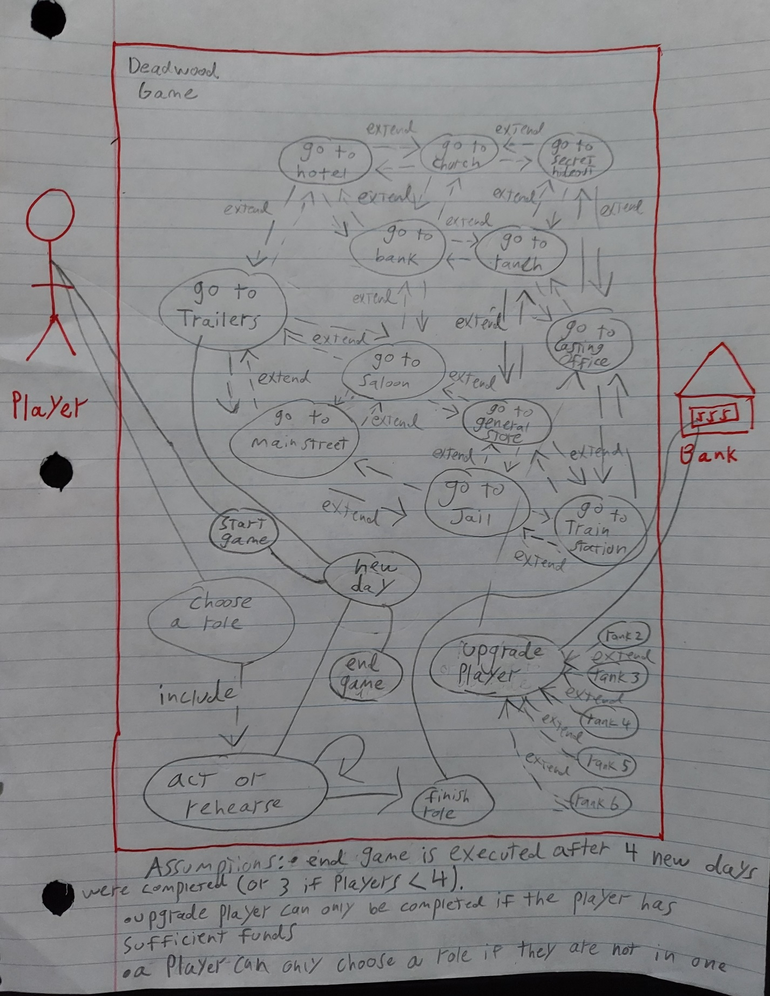

4.

Use Case Title: Start Game

Actors: Player

Trigger: Player wants to start a new game

Pre-condition: There are 2-8 players.

Post-condition: A new game starts

Basic Flow:

1. A new game starts
2. A new day starts
3. Player(s) goes to Trailers
4. ...

Use Case Title: Choose a role

Actors: Player

Trigger: A player wants to choose a new role

Pre-Condition: The player is not currently in a role and it is their turn and the role they want is not already preoccupied by another player.

Post-Condition: The player’s dice in on the role and they have to complete the role

Basic Flow:

1. Player chooses a new role
2. Player chooses to act
3. Player loses a shot
4. Player finishes role

Alternative Flow Step 2:

2a) Player chooses to rehearse

3a) Player chooses to act again

Alternative Flow Step 4:

4a) Player does not finish role with one shot left causing a new day to start

Use Case Title: Upgrade Player

Actors: Player, Bank

Trigger: A player in casting office chooses to upgrade their rank

Pre-condition: The player has enough funds to upgrade their rank

Post-condition: The player exchanges funds in exchange for the new rank

Basic Flow:

1. Player at casting office wants to upgrade rank
2. Player chooses rank to upgrade
3. Player gives funds to bank in exchange for rank
4. Player achieves new rank

Alternative Flow Step 3:

3a) Player does not have sufficient funds for new rank

3b) Player cannot get new rank and has to choose another option at casting office or select a new role.